The Parish of Bushey

S. James & S. Paul

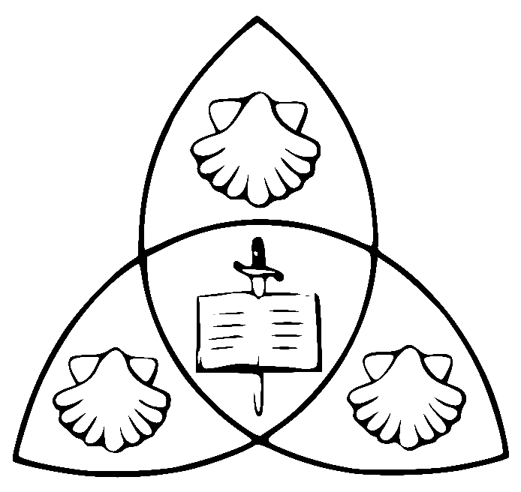

Parish Calendar

2024

Bushey Parish Liturgical Calendar 2024
SJ=St James Church Joint=Joint Service SP=St Pauls Church
Date | Day | Service/Event | Time
1st January | Monday | The Most Holy Name of Jesus | 12 noon
7th January | Sunday | The Epiphany of the Lord | 10:00am  11:15am
28th January | Sunday | Candlemas (SJ)  Candlemas (SP) | 10:00am  11:15am
14th February | Ash  Wednesday | Mass with Ashing (SP)  Solemn Mass with Ashing (SJ) | 12:30am  7:30pm
10th March | Mothering  Sunday | Lent 4 – Parish Eucharist (SJ)  Lent 4 – Sung Eucharist (SP) | 10:00am  11:15am
19th March | Tuesday | Blessed St Joseph (SJ) | 11:00am
24th March | Palm  Sunday | HOLY WEEK BEGINS  Mass & Procession (SJ - Joint) | 10:30am
25th March | Monday in Holy Week | Confession  Mass with Lent Reflection (SJ) | Appointment  7:30pm
26th March | Tuesday in Holy Week | Confession  Mass with Lent Reflection (SJ) | Appointment  7:30pm
27th March | Wednesday in Holy Week | Confession  Mass with Lent Reflection (SJ)) | Appointment  7:30 pm
28th March | Maundy  Thursday | Chrism Mass at S. Albans (Cathedral)  Mass with Washing of Feet  with Watch till Midnight (SJ) | 11:00am  8:00pm
29th March | Good  Friday | Family Stations of the Cross (SP)  Solemn Liturgy of Good Friday (SJ) | 11:00am  1:30pm
30th March | Holy  Saturday | Easter Vigil (SJ)  Easter Celebration Drinks | 7:30 pm  After Mass
31st March | Easter  Sunday | Parish Easter Eucharist (SJ)  Easter Eucharist (SP) | 10:00am  11:15am
9th April | Thursday | Ascension (SJ) | 7:30pm
10th April | Wednesday | Election of Church Wardens  APCM | 19:30pm  19:45pm
19th May | Sunday | Pentecost (SJ) | 10:30am
26th May | Sunday | Trinity Sunday (SJ) | 10:30am
23rd June | Thursday | Corpus Christi – with Procession and Benediction of the Blessed Sacrament (SJ) | 19:30pm
30th June | Sunday | Dedication Mass of S. Peter & S. Paul, Prince Apostles  (SP - Joint)  Parish Lunch @ S. Pauls | 10:30am  12 noon
25th July | Thursday | St James – Patronal Feast (SJ)  Followed by Drinks Reception | 7:30pm
14th August | Wednesday | The Assumption of the BVM (SJ) | 19:30pm
29th October | Sunday | Harvest Festival Eucharist  (SP - Joint)  Parish Harvest Lunch @ S. Pauls | 10:30am
2nd November | Saturday | All Souls – Solemn Requiem (SJ) | 11:00am
3rd November | Sunday | All Saints Sunday (SJ)  All Saints Sunday (SP) | 10:00am  11:15am
10th November | Sunday | Remembrance Sunday Eucharist (SJ)  Remembrance Sunday (SP)  Act of Remembrance at Bushey War Memorial – School Lane | 09:30am  10:50am  10:45am
11th November | Monday | Remembrance Day with an Act of Remembrance and Two Minutes Silence at 11am | 10:45 am
24th November | Sunday | Christ the Universal King Parish Eucharist (SJ - Joint)  (The Last Sunday of the Church Year)  Parish Lunch @ S. James | 10:30 am  12 noon
1st December | Sunday | The 1st Sunday of Advent  Year C (Year 1) Begins | 10:30am  11:15am
8th December | Sunday | Christingle | 16:00pm
22nd December | Sunday | Nine Lessons and Carols (SJ) | 6:30 pm
24th December | Tuesday | Crib Service (SJ)  Crib Service (SJ)  Crib Service (SP)  Midnight Mass (SJ) | 15:00pm  16:00pm  18:00pm  23:00pm
25th December | Wednesday | Mass of Christmas Day (SJ) | 10:00am
26th December | Thursday | Said Mass – S. Stephen (SJ) | 12:00noon
29th December | Sunday | The Most Holy Family | 10:00am  11:15am

Listed below are important HOLYDAYS (Holidays) in which we should pause from the cares of the world and focus our attentions upon heavenly things, rejoice, be with parish friends, family, and feast! These special Sabbaths are for us to reinvigorate our spiritual and bodily lives and are heavenly gifts for us all to enjoy.

A reminder of the Holy Days which you are strongly encouraged to come to Church:

- Every Sunday – Is a weekly Easter Day.
- The Epiphany – The Appearing and Revealing of the Lord Jesus.
- Ash Wednesday – Beginning of Lent.
- Blessed St Joseph – Patron of the Universal Church & Head of the Holy Family.
- Maundy Thursday – The Institution of the Holy Eucharist.
- Good Friday – The Passion and Death of our Saviour, Jesus Christ.
- Holy Saturday – The great Sabbath and Easter Vigil of the Resurrection.
- Easter Sunday – Holy Day of the Lords Resurrection.
- Ascension Day – The Return of Jesus into Heaven.
- Pentecost – The Coming of the Holy Spirit and Birthday of Holy Church.
- Corpus Christi – The Body and Blood of Jesus Christ.
- Trinity – The most Glorious, Undivided and Holy Trinity.
- S. Peter & S. Paul – The Princes Apostles of the Church.
- St James the Apostle – The Heavenly Patron of our Parish.
- The Assumption of the Blessed Virgin Mary, Mother of God, into Heaven.
- All Souls – Remembering all those who have died and gone before us.
- All Saints – The Feast of all God’s Holy Men, Women and Children.
- Christ the King – The Kingship of Jesus and end of the Church Year.
- 1st Sunday in Advent – First Sunday of the New Church Year.
- Midnight Mass – The first Mass and Welcoming of Christmas.
- Christmas Morning – The Christmas story continues.

- 12:30pm Every Wednesday – The Holy Eucharist at St Pauls.

- 11:00pm Every Thursday – The Holy Eucharist at St James.

- 3:30pm Every 2nd Wednesday of the Month – Messy Church at St Pauls.

- TBC - Choral Evensong.

- Lent Course followed by Lent Lunch will be held at St Pauls every Tuesday at 11am in Lent, followed by a soup, bread and cheese lunch.

- During Lent there will be an additional Lenten Reflection with our Bibles at St James, on the Sunday Gospel reading after the Thursday Eucharist at 11am.

With Prayers and Blessings for 2024.

